STEC
HP-UX PRoduction
Documentation

Prepared By:
Paul Buenrostro
Technical Documentation

Table of Contents
Overview 3
Network Diagram 3
Physical Network .
Wiring .
Hubs/switches .
Router .
Firewall .
Servers .
Server name .
Hardware .
Services .
IIS .
DNS .
Routing and Remote Access .
Backup 6
Overview 7
Hardware 6
Software 7
Tape Rotation 8
Peer-To-Peer Configuration 10
Printers 10

Overview
The STEC HP-UX environment runs ERP\CRM system.
ERP Systems integrate all data and processes of the organization into unified system.
CRM is a way of automating the front office functions of sales, marketing, and customer service.
Currently there is an active-standby server pair in the U.S and a single server in Malaysia.
Both sites replicate all databases to each other.

Network Diagram
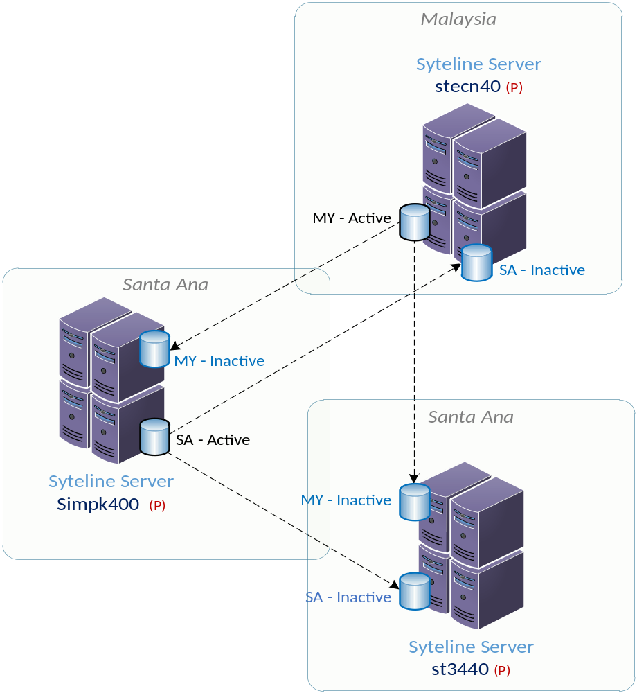

Servers
Make and Model | Model | IP Address | Site
Simpk400 | HP 9000 | 172.17.2.5 | SA
St3440 | HP 9000 | 172.17.2.193 | SA
Stecn40 | HP 9000 | 172.30.0.5 | MY

U.S Databases
Database | Description
SIL | Standard Syteline DB
SSOEM | Sister Customize DB to SIL
SYMGTBL | Global DB for Syteline contains Itemizer
SYMLIC | License manager for Syteline
CORP | Standard Syteline DB
USA | Standard Syteline DB
SMAL | Copy of SIL, SSOEM
SSMAL | Copy of SIL, SSOEM
Bold are replicated

Malaysia Databases
Database | Description
SMAL | Copy of SIL, SSOEM
SSMAL | Copy of SIL, SSOEM
SYMGLBL
SYMLIC | License manager for Syteline
CORP | Standard Syteline DB
USA | Standard Syteline DB

Directory structure
Sync’d Folders
/usr/simple
/usr/syteline
/users/mailpro/bin
Non-Sync’d Folders
/tmp/wrk
/tmp/synch/edi
/u4/temp/reports
/u4/temp/mthend
/u4/temp/cdw-ship
/users/agilex/ECN/archive
/users/edi/edidist/SIL/Arrow
/tmp/email
/u4/temp/Wachovia
/u4/temp/logs
/u4/temp/recsCount

Shared Directory structure
Simpk400 directories | NFS Client or Server
/users/samba | Mis-intranet (client)
/users/simpsamba | Mis-intranet (client)
/users/agilex | Mis-intranet (client)
/users/edi/edidist | Mis-intranet (client)
/u4/temp | Mis-intranet (client)
/tmp | Mis-intranet (client)
/u4/powerpack | Mis-intranet (client)
/backup | Sanfs01:/vol/vol1 (server)
/netapp2 | Sanfs01:/vol/vol2 (server)
/netapp2/dbattachments | Sanetapp02:/vol/vol0/htdocs (server)

External Server dependencies and services
Server(s) | Service(s) | Description
Saintwns1, saintwns2, saextwns1, saextwns3 | DB Name Server | Progress DB agent
Saintws1, saintws2 | WebSpeed | WebSpeed
Mis-intranet1, mis-intranet2 | Samba, NFS client, Intranet, Messenger | SMB access to NFS shares
Samissvn01 | SVN | Version control
Sawsdev1, sawsdev2 | Tortoise | Version control client
Stsql1 | SQL | SQL server
Sadc1, sadc2 | DNS | DNS servers
Sacas | Email | Email server

System Level Requirements
System Files | Description
/etc/passwd | Password file
/etc/exports | Shared file systems
/etc/hosts | Hosts file
/etc/shadow | Encrypted password file
/etc/fstab | File system table
/etc/services | Port Services

Cronjobs

..\Cronjobs.xlsx

Backup

Overview

Hardware
Hardware item | Description
Tape Drive
AutoLoader
Driver version
Updated/From

Software
Software item | Description
Backup Software
Version
Responsibilities
Day | Backup Details
Monday
Tuesday
Wednesday
Thursday
Friday
Saturday
Sunday

Tape Rotation
Su | M | Tu | W | Th | F | Sa

CRM Server

CRM Server Installation
Item | Data
Org name
Site name
Computer name
Service account
Service account password
Connectors

Peer-To-Peer Configuration
Computer | Share | Actual Location | Description | Security

Printers
Printer Type | Share | Location | IP Address | Security

